

Fallout 4: Become Humans

Version 1.0

|  |  |
| --- | --- |
| Designer: | Donghua Li |
| Document Date: | 2/20/2023 |
| Intended Level Delivery Date: | 4/24/2023 |

**Document Revisions Table**

|  |  |  |  |
| --- | --- | --- | --- |
| **Version** | **Description** | **Requestor** | **Date** |
| 1.0 | Level Design Document | Professor Myque Ouellette | 2/20/2023 |
|  |  |  |  |
|  |  |  |  |
|  |  |  |  |
|  |  |  |  |

## Table of Contents

Table of Contents 2

Table of Figures 4

Level Summary 5

Quick Summary 5

Level Feature Overview 5

Development Schedule 6

Level Overview 7

Exterior Overview Map 7

Interior Overview Map 8

Narrative Flow Chart 9

Level Details 10

Detail Maps 10

Legend for Exterior Area 10

Legend for Ruined Church, Command Center, EB1, and EB2 11

Silent Wind Monastery Front Walkthrough 12

Silent Wind Monastery Courtyard 14

Legend for Interior Area 16

Interior First Floor in *SWM* 17

Interior Second Floor in SWM 20

Ruined Church Walkthrough 24

Skill Progression Chart 26

Aesthetic References 27

Monastery Environment Appearance Reference 27

Silent Wind Monastery Exterior Appearance Reference 28

Interior Decoration Reference 29

References 30

Appendices 32

Appendix A: New Skills / Gameplay Mechanics 32

EMP Grenade 32

Bookshelf Sliding Door 32

Appendix B: Context Detail 33

General Context 33

Backstory 33

Aftermath 33

Narrative Summary 33

Appendix C: Character Descriptions 36

NPC 1: Kala 36

NPC 2: Alice 36

NPC 3: Cornar 36

NPC 4: Antoniadis 36

NPC 5: Gaven 37

NPC 6: Bayul 37

Appendix D: Dialog Flow 37

Appendix E: Development Risks 38

Appendix F: Key Asset Needs 39

## Table of Figures

Figure 1: Become Humans Level Exterior Overview Map [6] 7

Figure 2: Become Humans Level Interior Overview Map [6] 8

Figure 3 Narrative Flow Chart [1] 9

Figure 4 Legend for Exterior Area [6] 10

Figure 5 Legend for Ruined Church, Commander Center, FB1, and FB2 [6] 11

Figure 6: Silent Wind Monastery Front Walkthrough [6] 12

Figure 7: Silent Wind Monastery Courtyard Walkthrough [6] 14

Figure 8 Legend for Interior Area [6] 16

Figure 9: Interior First Floor Walkthrough [6] 17

Figure 10: Interior Second Floor Walkthrough [6] 20

Figure 11: Ruined Church Walkthrough [6] 24

Figure 12 Skill Progression Chart [5] 26

Figure 13 General Concept of Silent Wind Monastery [2] 27

Figure 14 Contact Sheets of SWM’s Exterior Appearance [3] 28

Figure 15 Contact Sheets of SWM’s Interior Appearance [4] 29

# Level Summary

## Quick Summary

***Become Humans***  is a single-player quest in Fallout 4 starting by talking to an agent who is recruiting mans for **Dr. Cornar**, an old scientist once worked for the Institute. Dr. Cornar’s mercenary troop is attacking the ***Silent Wind*** **Monastery( SWM)** in order to save his daughter, **Kala**, from a 3rd- Gen Synth called **Alice** who kidnapped her. Alice is the maid of Cornar’s family who took care of Kala from her infanthood, and she kidnapped Kala because something goes wrong in her neuro control units according to Cornar.

Armed with EMP Grenades that only affects machines, the player chases Alice in the monastery to find Kala by smashing down 1st-Gen Synths, Railroad agents that support Alice, and turrets. The player will also encounter turrets, laser mines, and several challenging interior combat encounters with Alice’s troop and discovers that Kala is not kidnapped by Alice as what Cornar said but for another reason.

## Level Feature Overview

|  |  |  |
| --- | --- | --- |
| Category | Sub-Category | Feature List |
| Player | Player Weapons | * Institution Laser Gun * Emp Grenade (New weapon) * Laser Gun * Baton * Pipe Gun (Loot) * Pipe Bolt Action (Loot) * Assault Rifle (Fetch by exploration) * Double Barrel Shotgun (Fetch by exploration) |
|  | Player Skills/Abilities | * With EMP grenade   + Stun Synths with Emp Grenades   + Stun Turrets with Emp Grenades   + Stun Laser Mines with Emp Grenades   + Stun Terminal to make the door it locks open * Disactivate Turrets with Terminals * Open doors by hacking Terminals * Lockpicking * Charisma Check * Stealth for stealing or attacking enemies * Chess-shelf puzzle and sliding door (Classic logic puzzle) |
| AI | Enemies | * 1st – Gen Synth (melee and ranged) * Railroad agents (melee and ranged) * Turrets * Alice (If chooses to kill Alice and take Kala back) * Mercenary (If choose to let Alice and Kala run away) * **Antoniadis** (Commander of Mercenary, if choose to let Alice and Kala run away |
|  | Friendlies | * TBD |
| Challenges | Gameplay Themes | * EMP disactivating turrets and laser mine traps * Stun and shoot the Synth and turrets * Multiple solutions to laser mine traps |
|  | Obstacles/Hazards | * Turrets * Locked doors with terminal * Locked doors that requires lockpicking * Laser mine trap |
|  | New/Unique Gameplay | * EMP Grenade * Sliding Bookshelf Door triggered by button |
| Context | Where Fits in Game | * Monastery that has decals indicating intensive fight between mercenary faction and Alice’s faction * Turrets and Traps are placed in hallway and room, which indicates Kala is guard by Alice very well |
|  | Challenge Fit | * Use EMP grenade to stun Synth in encounters formed by humans and Synths, to deal with the human first * With limited amount of emp grenades, the player needs to decide where to use them including:   + In combat   + Stun Turrets   + Stun laser mines hidden in wall   + Stun terminal to make it easier to hack |
|  | Additional Info | N/A |
| Aesthetics | Major Visual Themes | * Monastery (exterior and interior) * Church (exterior and interior) |
|  | Setting/Mood | * Bright * Sunny |

## Development Schedule

|  |  |
| --- | --- |
| Milestone | Date |
| LDD | 2/20/2023 |
| Whitebox | 3/6/2023 |
| Initial Gameplay | 3/27/2023 |
| Gameplay Complete | 4/17/2023 |
| Aesthetics | 4/24/2023 |
| Launch | /5/1/2023 |

## Level Overview

### Exterior Overview Map

­­ 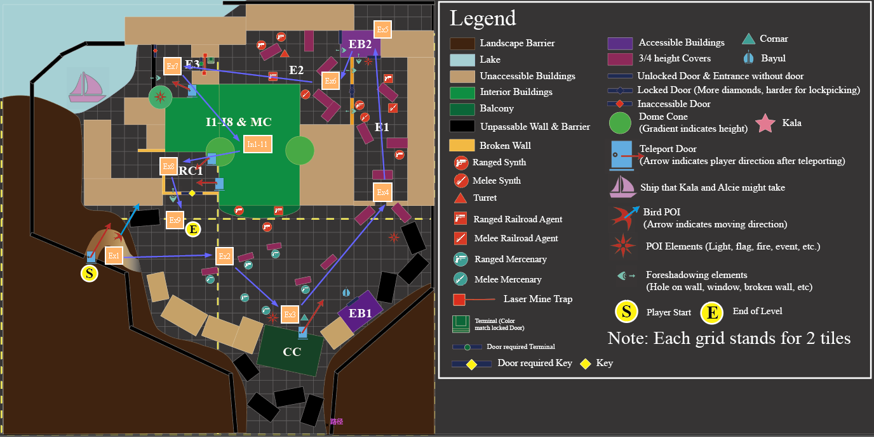­­

Figure : Become Humans Level Exterior Overview Map [6]

|  |  |
| --- | --- |
| Map Label | Gameplay Summary |
| Ex1 | The player gets the quest from **Gaven** at ***Red Rocket Ext*** travels to ***SWM*** region. A footman leads the player to the ***CC (Command Center)*** |
| Ex2 | The player witnesses that mercenaries are fighting with Synths and Railroad agents |
| Ex3 | The player talks to Cornar (outside the ***CC***) and Antoniadis (inside the ***CC***), get the goal and details of the quest |
| Ex4 | The player starts to break in ***SWM*** from its right side and encounters the first exterior combats |
| Ex5 | The player crosses the broken wall to reach ***E2***, by either lockpicking or hacking the terminal in ***EB2*** |
| Ex6 | The player encounter the second exterior combat |
| Ex7 | The player crosses the laser mine trap by either hacking the terminal or use the EMP grenade to disarm mines |
| In1-In11 | [Main Encounter] The player enters the main building of ***SWM***, where he completes most of the narrative. Look at the next section below for details |
| Ex8 | [Main Encounter] The player exits the main building of ***SWM***, and talk to **Alice** and **Kala** for main choice and complete the combat with respect to the choice |
| Ex9 | The player exits ***SWM*** and talk to Cornar waiting outside the wall. Quest complete |

### Interior Overview Map

­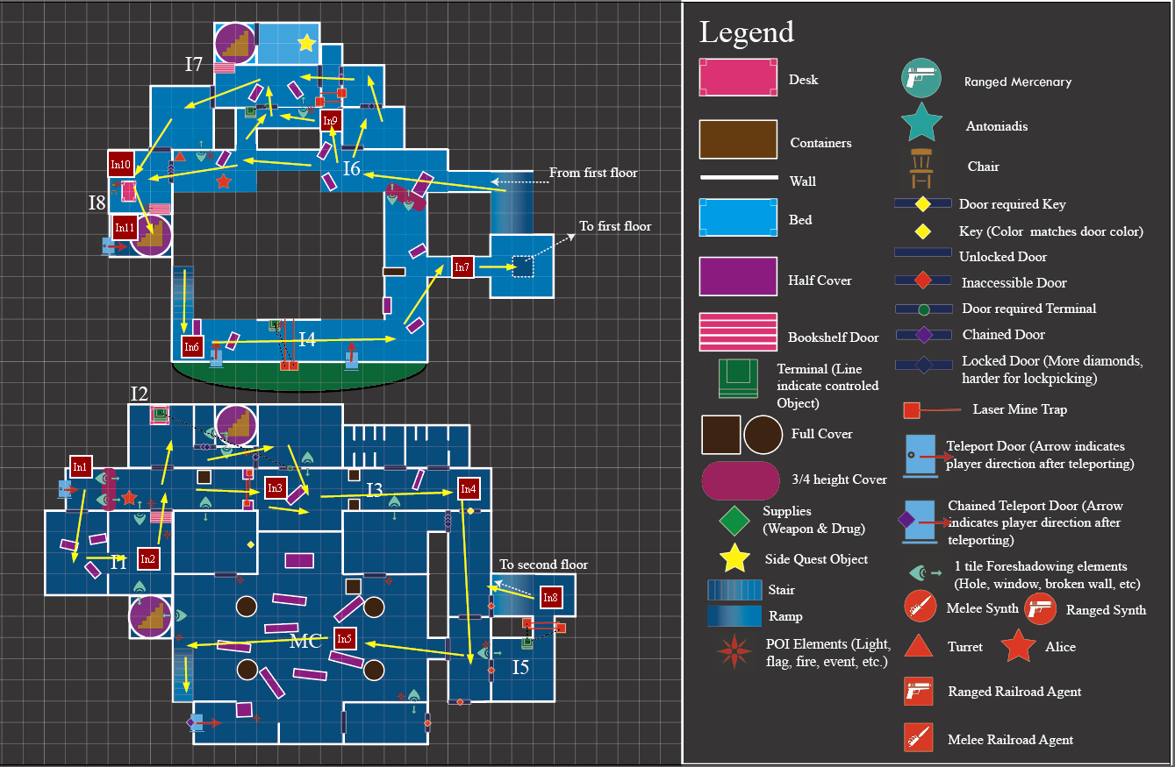­­

Figure : Become Humans Level Interior Overview Map [6]

|  |  |
| --- | --- |
| Map Label | Gameplay Summary |
| In1 | The player enters ***SWM*** main building from its back door and see Alice behind the obstacle in front. Alice runs away to the end of the hallway. The player needs to catch up with her |
| In2 | The player explore room **I1**. After combat, the player leaves **I1** by opening bookshelf door |
| In3 | The player keeps moving forward in **I2** by either bypassing the laser mine trap or disarming it with Emp grenade, after defeating enemies on the hallway |
| In4 | The player defeats newly encountered enemies and retrieve a key from the dead body in **I3**. The player opens the door and go ahead to the **MC (Main Church)** area |
| In5 | In the **MC** area, the player talk to Alice who is on the balcony on the second floor. Alice runs into **I8** rooms after commanding her ambush synths and ambush railroad agents to assault |
| In6 | The player keeps tracing Alice by going upstairs and reach **I4** area |
| In7 | The player defeats several enemies and move forward in **I4** until a ¾ height obstacle block the way. The player then find a hold on the floor and jump into it to **I5** |
| In8 | In room **I5**, the player reaches the ramp going up to the second floor after disarming the laser mine via hacking the terminals or Emp grenade |
| In9 | The player needs to find a way to enter Room **I8,** which Alice went into. Multiple ways to get to **I8** are proved to the player for options.  [Side Quest] The player opens the bookshelf door and find a spiral stair to the third floor where the player can get the quest item |
| In10 | After reaching room **I8**, the player cannot find Alice and he/she needs to open the bookshelf door to get access to the hidden spiral stairs behind the wall to move forward |
| In11 | The player reaches the bottom of the hidden stairs and leave the building for **Ex8** |

## Narrative Flow Chart

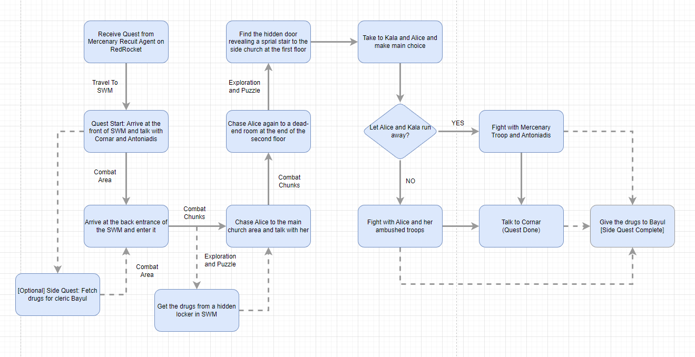

Figure Narrative Flow Chart [1]

# Level Details

## Detail Maps

### Legend for Exterior Area

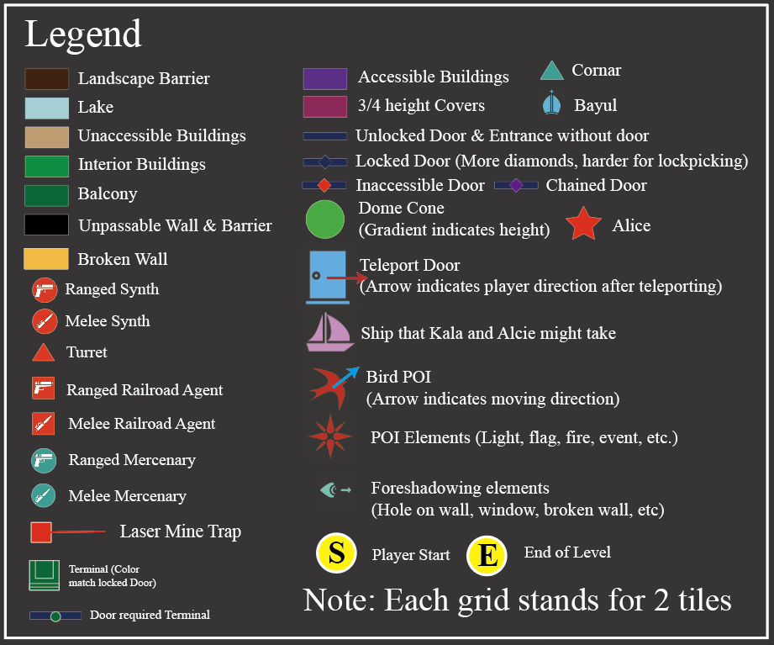

Figure Legend for Exterior Area [6]

### Legend for Ruined Church, Command Center, EB1, and EB2

Figure Legend for Ruined Church, Commander Center, FB1, and FB2 [6]

### Silent Wind Monastery Front Walkthrough

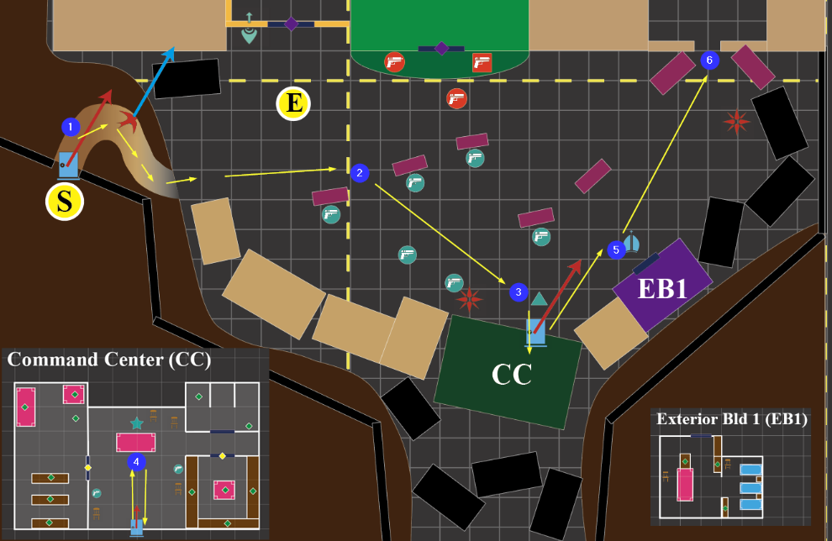

Figure : Silent Wind Monastery Front Walkthrough [6]

|  |  |  |
| --- | --- | --- |
| Map Label / Stage | Event Summary | Event Details |
| 1 | Player reaches ***SWM*** from ***Red Rocket Ext*** | * The player reaches **SWM** via teleport door and meet a footman waiting for him. * The footman greets with the player and ask the player to follow him to where Dr.Cornar is |
| 2 | Player reaches about the center of the ***SWM*** front | * The player sees the combat between mercenaries and Alice’s synths and Railroad agents |
| 3 | The player talk with Dr. Cornar and the he asks the player to talk to Antoniadis in the ***CC*** | * Narrative: Stage 20 * The player is asked to talk to Antoniadis for more details about attacking the monastery * The player enters **CC** * Resources:   + 100 Caps (Charisma Check from Cornar) |
| 4 | The player enters ***CC*** and talk to Antoniadis | * Narrative: Stage 40 * The player is asked to get into the church and rescue Kala * Antoniadis introduces Emp Grenade to the player * Resources:   + Emp Grenade   + Institute Laser Gun   + Laser Gun   + Baton   + Medicine Resource   + Energy Ammo   + Mercenary Outfit |
| 5 | [Optional] Talk to Cleric Bayul for the side quest | * Narrative: Stage SQ-10 * Resource   + Chems   + Medicine |
| 6 | The player reaches the side entrance of the ***SWM*** and start to break in | * The player sees the side entrance of the ***SWM*** and starts to search for Kala and Alice |

### Silent Wind Monastery Courtyard

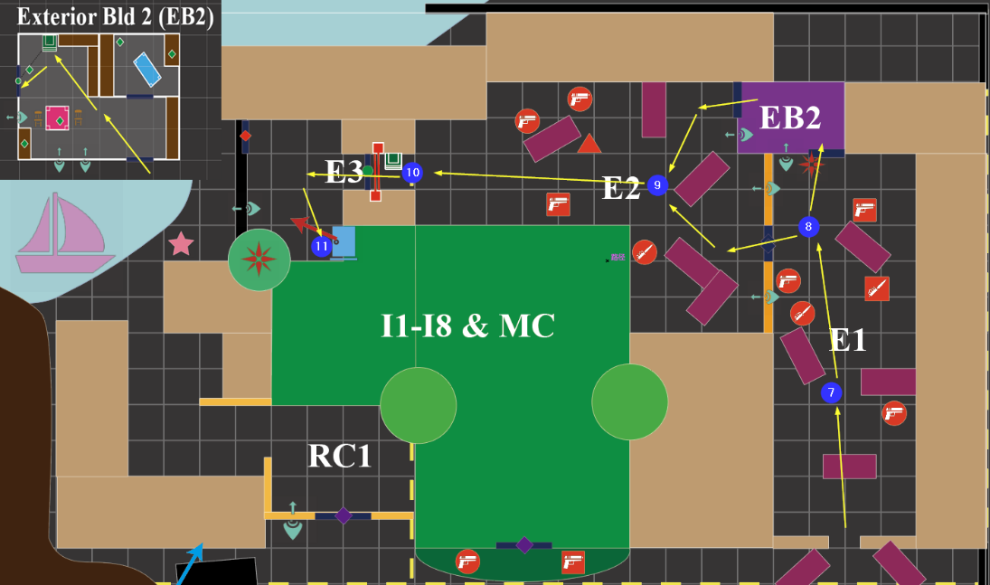

Figure : Silent Wind Monastery Courtyard Walkthrough [6]

|  |  |  |
| --- | --- | --- |
| Map Label / Stage | Event Summary | Event Details |
| 7 | The player enters the courtyard of ***SWM*** and encounters the first enemy | Enemies   * Ranged Synth * 1 |
| 8 | The player moves forward and encounter mixed types of enemies. | * Enemies:   + Melee Synth * 1   + Melee Agent * 1   + Ranged Synth * 1   + Ranged Agent * 1 * After defeating enemies in **E1** area, the player needs to find a way to cross the broken wall with a lock door on it * The player can cross the broken wall by:   + Hacking the terminal in **EB2**   + Lockpick the door on the broken wall using bobby pins * Resource   + Medicine   + Pipe Gun (Loot)   + Pipe Bolt Action (Loot)   + Bobby pins |
| 9 | The player cross the broken wall and encounter enemy troop with turret | * Enemies   + Melee Synth * 1   + Ranged Synths * 2   + Ranged Agent * 1   + Turret * 1 |
| 10 | The player moves forward and manage to go on a small path that is block by laser mine with a terminal in front of it | * The player can disarm the laser mine via:   + Hacking the terminal on the wall   + Use Emp to disable all the laser mine * The terminal can also open the door for the player |
| 11 | The player finds the back door of ***SWM*** and enter the interior space | The player is able to see Kala by the ship that she and Alice will take for escaping from the monastery from the hole on the wall |

### Legend for Interior Area

Figure Legend for Interior Area [6]

### Interior First Floor in *SWM*

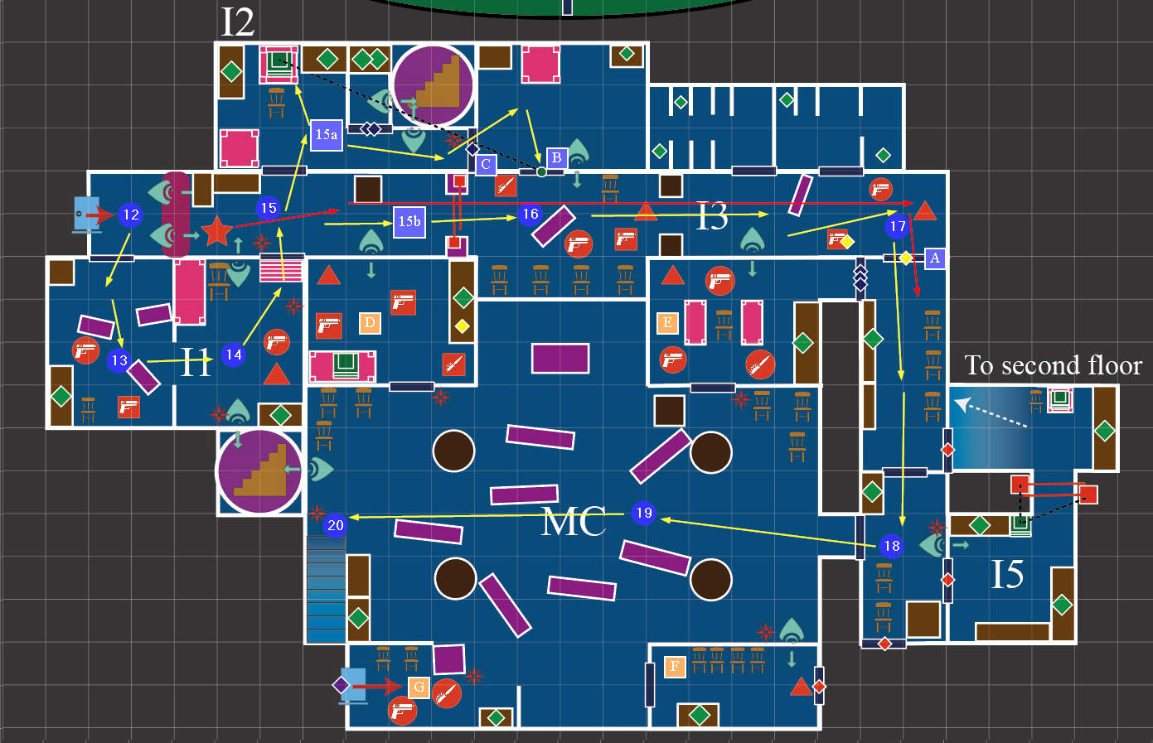

Figure : Interior First Floor Walkthrough [6]

|  |  |  |
| --- | --- | --- |
| Map Label / Stage | Event Summary | Event Details |
| 12 | The player enters the ***SWM*** from its back door and see Alice behind a ¾ height obstacle | * Narrative: Stage 60 * The player can see the bookshelf door is closing after the dialog ends and Alice is run away toward the end of the hallway * The **Red Line** in the map indicates the walk path of Alice and it is a ghost Alice technically, it will disappear as soon as the door **A** closes |
| 13 | The player enters the **I1** rooms to open the bookshelf door to catch up with Alice | * Enemies   + Ranged Synths * 2   + Ranged Agent * 1   + Turret * Supplies   + Ammo   + Emp Grenade (From Mercenary dead body) * The player can shoot the turret to dead or use Emp grenade to stun them before shooting them |
| 14 | After clearing room **RI**, the player need to find how to open a bookshelf door | * The bookshelf door can be opened if the player presses a button under the desk in the room * After the button is press, the light above the bookshelf will light up * As much as possible, furniture in the room are in the same color as the color of the light above the bookshelf * The player can see a hidden spiral stair from the hold on the wall |
| 15 | The player reaches the hallway and start to trace Alice | * The player finds there is laser mine traps blocking the hallway |
| 15a | The player bypass the laser mine trap | * The player enters room **I2** and use the terminal there to open the door **B** after opening the door **C** by lockpicking * Supplies   + Medicine   + Ammo   + Assault Rifle (Need Lockpicking)   + Emp Grenade (Need Lockpicking) * The player is able to see a hidden spiral stair from the holes on the wall |
| 15b | The player cross the laser mine trap by disarming it | * The player disables the laser mines by Emp grenade and move forward * From the holes on the wall, the player is able to see enemies patrolling in the room **D** |
| 16 | The player encounters new enemies in the middle part of the hallway | * Enemies:   + Ambush Melee Railroad Agent * 1   + Ranged Railroad Agent * 1   + Ranged Synths * 1   + Turret * The player can stun the turret and synths by Emp grenade and deal with the railroad agents first |
| 17 | The player reaches **I3** and sees Alice exits the hallway from door **A** and close it. | * Enemies:   + Turret * 1   + Ranged Railroad Agent * 1   + Ranged Synths * 1 * The player is able to see enemies patrolling in room **E** from the hole on the wall * The player can stun the turret with emp and deal with other first * The player will get a key from the loot of the Ranged Railroad Agent to open the door **A** * Supplies:   + Medicine   + Chems   + Emp Grenade |
| 18 | The player walk forward and take a rest from the intensive combat before | * Supplies   + Chems   + Ammo * If the player has high skills of lockpicking, he is able to unlock door to room E and deal with the synths there in advanced * The player is able to see the room **I5** from the window on the wall near the entrance of **MC** |
| 19 | The player enters the **MC** area and talk to Alice who is at the balcony at the second floor (See the next section for details of location) | * Narrative: Stage 80 * The player talks to Alice for narrative. After that, Alice will call the ambush enemies form room D and E to attack the player and runs into room **I8** (See the next section for details of location) * Enemies:   + Ranged Synths * 2   + Ranged Railroad * 2   + Melee Synths * 1   + Melee Railroad * 1   + Turrets * 2 * The player can explore rooms **D**, **E**, **F**, and **G** after defeating all the ambush enemies and is able to find a key in room **D** for the balcony on the second floor * Supplies   + Medicine   + Chems   + Ammo   + Emp Grenade |
| 20 | The player goes upstairs to track Alice again (To the second floor section) | * The player is able to see the hidden spiral stair again from the hole on the wall |

### Interior Second Floor in SWM

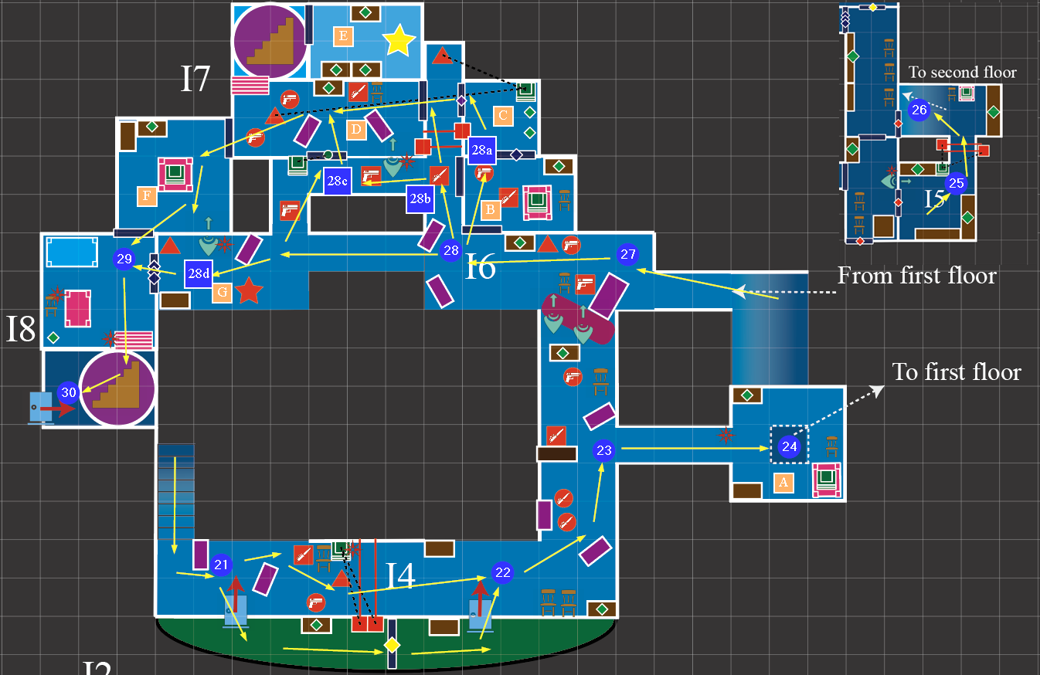

Figure : Interior Second Floor Walkthrough [6]

|  |  |  |
| --- | --- | --- |
| Map Label / Stage | Event Summary | Event Details |
| 21 | The player reaches the second floor from the stair | / |
| 22 | The player encounters with 3 enemies and manage to cross the laser mine trap blocking the hallway | * Enemies   + Turret * 1   + Melee Railroad Agent * 1   + Ranged Synths * 1 * After defeating all the enemies, the player can cross the laser mine trap by:   + Hacking the terminals that closes the trap   + Use emp grenade to disable the laser mine trap   + Bypass it by going to the exterior balcony colored in green in the map and open the door there with the key founded in room D on the first floor to return to the interior area * Resources   + Ammo   + Emp Grenade   + Medicine |
| 23 | The player encounters ambush enemies and find the hallway is blocked by ¾ height obstacle | * Enemies   + Melee Railroad Agent * 1   + Ranged Synths * 1   + Melee Synths * 2 * Resource   + Ammo * The player can see there is a turret in the **I6** area but cannot shoot it effectively |
| 24 | The player jump down to the first floor to seek a way back to the second floor | The player goes to room **A** and jump into the hole to reach room **I5** to seek a way back to the second floor   * Resource   + Ammo |
| 25 | The player manages to pass the laser mine trap block the way to another part of the room | * The player can disable the laser mine trap by Emp Grenade * The player can hack the terminals to disactivate the laser mine trap * Supplies   + Ammo   + Medicine   + Chems |
| 26 | The player crosses the laser mine trap and fine a ramp going back to the second floor | * Supplies   + Ammo   + Medicine   + Emp Grenade * The player can hack the terminal here for more information about Alice and Kala |
| 27 | The player goes back to the second floor by climbing the ramp and encounter with new enemies | * Enemies   + Turret * 1   + Ranged Synths * 1   + Ranged Railroad Agent * 1 * Supplies   + Ammo |
| 28 | The player manages to find a way to get in the room **I8** where Alice got in before | * Narrative: Stage SQ-20 * The player have four ways to reach room **I8** according to their skill configurations and preference. The four ways are detailed in **28a, 28b, 28c, and 28d** * If the player enters the room **D**, he/she can get access to the third floor where the side quest is by pressing the button among the container * Each way to reach room **I8** provides different supplies |
| 28a | The first way to reach room **I8** is to explore room **B**, **C**, **D**, and **F** | 1. The player defeats two enemies (a melee railroad agent and a ranged synths) in room **B** 2. Lockpick the door to room **C** and use the terminal there to unlock the door at the left side of room **C** The player can also disactivate the turrets in the hallway and in the room **D** by this terminal 3. Enter room **D** from its right side and defeat the enemies in it (turret * 1, ranged synths *2, melee railroad agent * 1) 4. Enter the room **F** 5. Enter the room **I8**  * Supplies:   + Ammo   + Chems   + Medicine   + Emp Grenade   + Double Barrel Shotgun |
| 28b | The second way to reach room **I8** is to manage to pass the hallway where the laser mine is and enter room **D** from its right side. Then, reach **I8** by walking through room F | 1. Disarm the laser mine trap in the hallway by Emp grenade after defeating the enemies (melee Railroad agent * 1, range railroad agent *2) in it 2. Enter room **D** from its right side and defeat the enemies in it (turret * 1, ranged synths *2, melee railroad agent * 1) 3. Enter the room **F** 4. Enter the room **I8**  * Supplies:   + Ammo   + Medicine   + Emp Grenade |
| 28c | If the player have not bobby pin and Emp grenade, hacking the terminal at the bottom side of room D can help the player reaches room **I8** | 1. Defeat the enemies (melee Railroad agent * 1, range railroad agent *2) in the hallway 2. Hack the terminal by the door at the bottom side of room **D** to the door 3. Enter room **D** from its bottom side and defeat the enemies in it (turret * 1, ranged synths *2, melee railroad agent * 1) 4. Enter the room **F** 5. Enter the room **I8**  * Supplies:   + Ammo   + Medicine   + Emp Grenade |
| 28d | If the player has a good perks of lockpicking, he/she can enter room **I8** directly by lockpicking | 1. Go straightforward and defeat the turrets at balcony **G** 2. Lockpick the door at balcony **G** and enter room **I8**  * Supplies:   + Medicine |
| 29 | The player cannot find Alice in the dead-end room **I8**. The player manages to find a hidden spiral stair behind the bookshelf | * The player opens the bookshelf door in room **I8** and find a hidden spiral stair * To open the bookshelf door in room **I8**, the player need to have 3 buttons pressed to open it * The red button is in room **I8** * The blue button is in room **D** * The green button is in room **B** |
| 30 | The player goes downstair and exits the interior area and reach **Ruined Church (RC1)** | / |

### Ruined Church Walkthrough

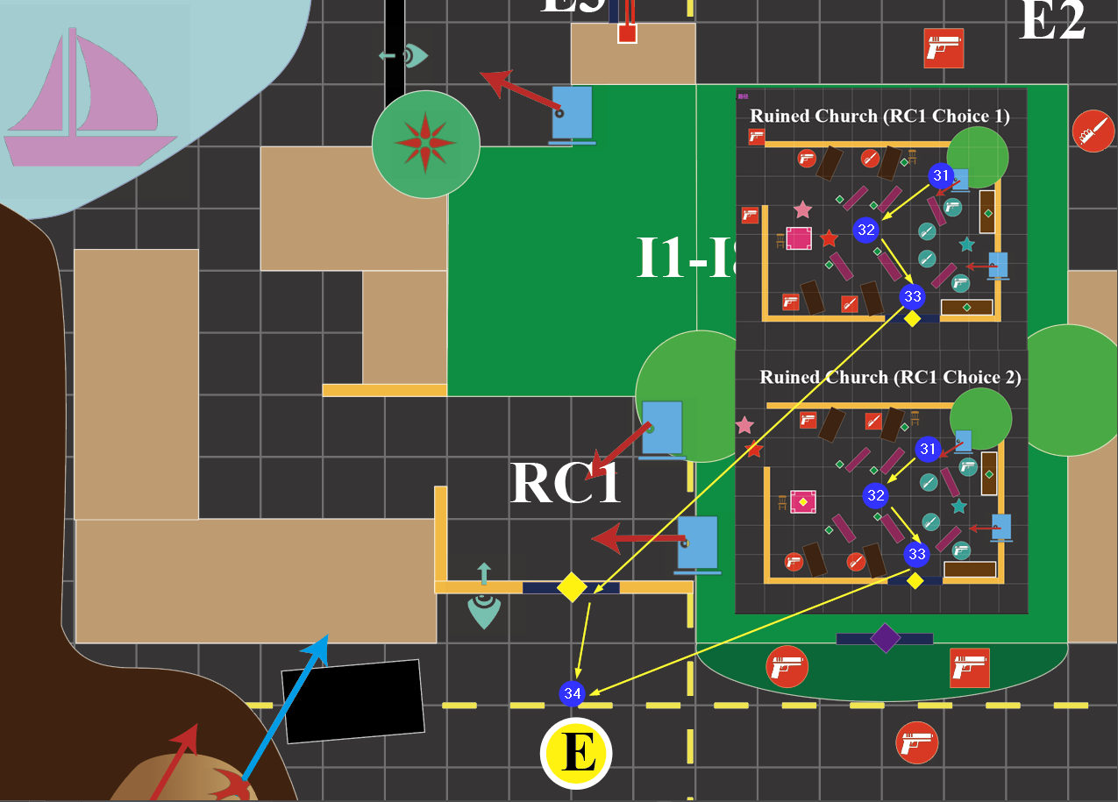

Figure : Ruined Church Walkthrough [6]

|  |  |  |
| --- | --- | --- |
| Map Label / Stage | Event Summary | Event Details |
| 31 | [Main Choice]  The player exits from the **SWM** interior area and talk to Alice and Kala when he/she is about the center of the church | * Narrative: Stage 120 * The player sees Alice and Kala standing together * When the player reaches the ruined church, the player can only see Alice and Kala * Synths and Railroad agents will keep ambushing until the player make main choices * Mercenaries and Antoniadis will not be there at the beginning, they shows up after the player makes main choices * The dialog between Kala, Alice, and the player will start when the player reach about the center of the church |
| 32 | [Main Encounter]  The combat will be sightly different according to which side the player supports | * No matter which side the player support, all ambush synths and railroad agents will show up * If the player **supports** **Alice and Kala**, they will run away via the breach of the ruined church. The player needs to help them to defeat Antoniadis and his men who are breaking in when they are talking in stage 31.   + Narrative Stage: Stage 120   + Ambush Synths, railroad agents will become friendly and help the player defeat Antoniadis and his men   + Antoniadis and his men will become hostile to the player   + The key for the exit door of the ruined church will be left on the desk   + Enemies     - Melee Mercenaries * 2     - Ranged Mercenaries * 2     - Antoniadis * If the player **supports Cornar** and wants to take Kala back, Alice will become hostile, and Kala will hide behind the cover until the combat end   + Narrative: Stage 220   + Antoniadis and his men will help the player defeat Alice, all synths, and all railroad agents   + The player can get the key to the ruined church from Alice loot   + Enemies     - Melee Synth * 1     - Ranged Synth * 1     - Melee Synth * 1     - Ranged Railroad Agent * 1     - Alice * Supplies   + Medicine   + Ammo   + Emp Grenade |
| 33 | After defeating all the enemies, the player can open the locked door with the key to leave the ruined church | / |
| 34 | Talk to Cornar to finish the quest.  [Side Quest]  Talk to Bayul to complete the side quest | * Narrative: Stage 300, SQ-30 |

## Skill Progression Chart

Figure Skill Progression Chart [5]

## Aesthetic References

***Become Humans’*** takes place in a monastery with the name of Silent Wind Monastery. It is located in a forest by the lake. Around the monastery, there is several houses and buildings that are still used by people in this region.

The exterior appearance of the monastery will be decorated with divine elements which inspire the idea of religion and holiness. Also, the exterior environment will be decorated in post-apocalypse style while having details telling the it is still used by people in this area.

For the interior area, it is classic monastery style with brick and wood as its basic elements of construction. Yet, the interior appearance will be shabby that damaged wall, windows, and furniture from the past can be seen everywhere

### Monastery Environment Appearance Reference

Figure General Concept of Silent Wind Monastery [2]

### Silent Wind Monastery Exterior Appearance Reference

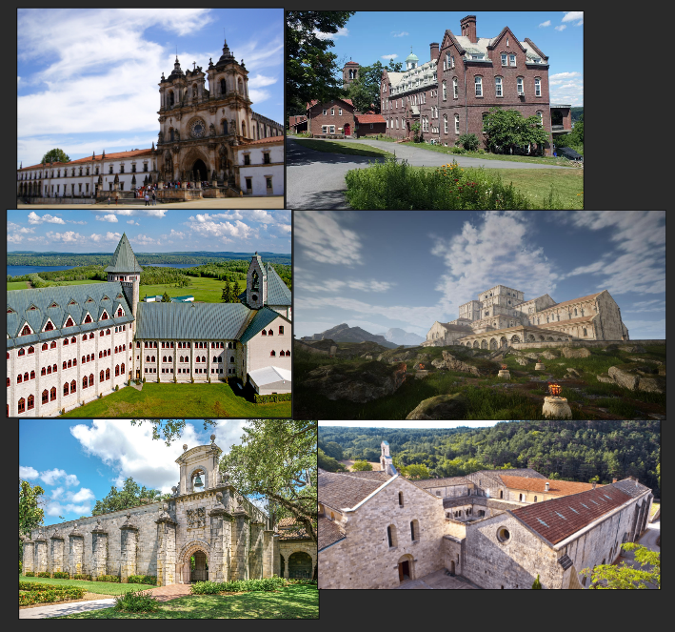

Figure Contact Sheets of SWM’s Exterior Appearance [3]

### Interior Decoration Reference

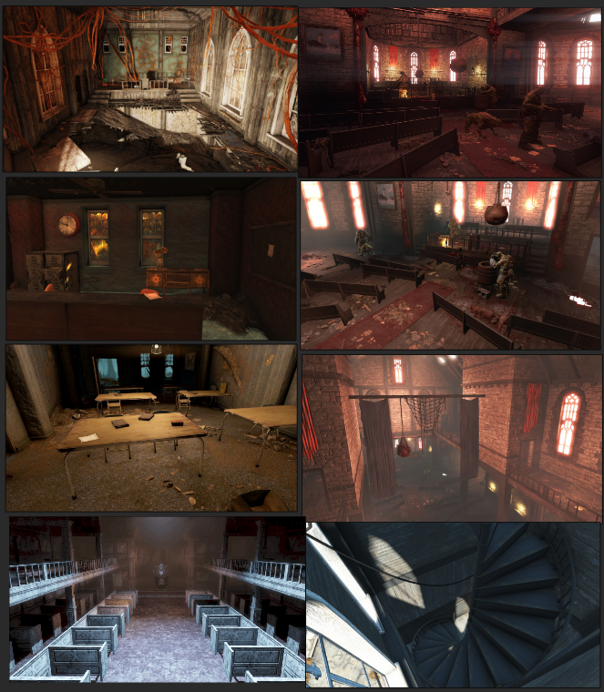­

Figure Contact Sheets of SWM’s Interior Appearance [4]

# References

[Cover Image] A. Chia, “In Living memory: Understanding hyperthymesia,” Grey Matters, 27-Jul-2021. [Online]. Available: https://greymattersjournal.org/in-living-memory--understanding-hyperthymesia/. [Accessed: 19-Feb-2023].

[1] Li, Donghua, “Narrative Flow Chart”, created by diagrams.net, Feb. 16, 2023.

[2] M. A. T. T. H. E. W. ALDERMAN, “A new monastery in the Midwest,” New Liturgical Movement. [Online]. Available: https://www.newliturgicalmovement.org/2012/10/a-new-monastery-in-midwest.html#.Y_HG-nbMKUk. [Accessed: 19-Feb-2023].

[3] Li, Donghua, “Contact Sheets of SWM’s Exterior Appearance”, created by Pureref, Feb. 19, 2023.

M. Kaplan, “10 amazing Christian monasteries,” Touropia. [Online]. Available: https://www.touropia.com/amazing-christian-monasteries/. [Accessed: 19-Feb-2023].

E. Arneson, “10 monasteries where you can spend the night in the U.S.,” TripSavvy, 27-Dec-2019. [Online]. Available: https://www.tripsavvy.com/monastery-stays-in-the-united-states-4779957. [Accessed: 19-Feb-2023].

“Gallery,” Good Night and God Bless. [Online]. Available: https://www.goodnightandgodbless.com/gallery/trappist-abbey-massachusetts-usa/39. [Accessed: 19-Feb-2023].

“Romanesque monastery in environments - UE marketplace,” Unreal Engine, 21-Dec-2021. [Online]. Available: https://www.unrealengine.com/marketplace/en-US/product/romanesque-monastery. [Accessed: 19-Feb-2023].

Karl, “Visiting an ancient Spanish monastery - in Florida??,” DrFumblefinger's Adventures of a Lifetime, 21-Oct-2019. [Online]. Available: http://drfumblefinger.com/blog/2019/10/visiting-an-ancient-spanish-monastery-in-florida/. [Accessed: 19-Feb-2023].

C. Besse, J. Burkepile, A. J. and J. Burkepile, A. Jaromezuk, and C. Perkins, “French monastery survives War &amp; Famine after 885 years - what the monks do now is amazing,” French Monastery Survives War &amp; Famine After 885 Years - What The Monks Do Now is Amazing -, 22-Dec-2022. [Online]. Available: https://www.churchpop.com/2022/12/22/french-monastery-survives-war-famine-after-885-years-what-the-monks-do-now-is-amazing/. [Accessed: 19-Feb-2023].

[4] Li, Donghua, “Contact Sheets of SWM’s Interior Appearance”, created by Pureref, Feb. 19, 2023.

“Haven Church,” Fallout Wiki. [Online]. Available: https://fallout.fandom.com/wiki/Haven_Church. [Accessed: 19-Feb-2023].

“Trinity Church,” Fallout Wiki. [Online]. Available: https://fallout.fandom.com/wiki/Trinity_Church. [Accessed: 19-Feb-2023].

ThatMrSmile, “Screenshot :: Trinity Church,” Nexus Mods :: Fallout 4, 30-Aug-2019. [Online]. Available: https://www.nexusmods.com/fallout4/images/157894. [Accessed: 19-Feb-2023].

Fallout 4 Mods, “Old north church remake - fallout 4 mod download,” Fallout 4 Mods, 18-Oct-2020. [Online]. Available: http://www.modsfallout4.com/old-north-church-remake/. [Accessed: 19-Feb-2023].

“Quincy Church,” Fallout Wiki, 17-Jun-2022. [Online]. Available: https://fallout.fandom.com/wiki/Quincy_church. [Accessed: 19-Feb-2023].

[5] Li, Donghua, “Skill Progression Chart”, created by Microsoft Excel, Feb. 19, 2023.

[6] Li, Donghua, “Become Humans Level Exterior Overview Map”, created by Adobe Illustrator, Feb. 19, 2023.

Li, Donghua, “Become Humans Level Interior Overview Map”, created by Adobe Illustrator, Feb. 19, 2023.

Li, Donghua, “Legend for Exterior Area”, created by Adobe Illustrator, Feb. 19, 2023.

Li, Donghua, “Silent Wind Monastery Front Walkthrough”, created by Adobe Illustrator, Feb. 19, 2023.

Li, Donghua, “Silent Wind Monastery Courtyard Walkthrough”, created by Adobe Illustrator, Feb. 19, 2023.

Li, Donghua, “Legend for Interior Area”, created by Adobe Illustrator, Feb. 19, 2023.

Li, Donghua, “Interior First Floor Walkthrough”, created by Adobe Illustrator, Feb. 19, 2023.

Li, Donghua, “Interior Second Floor Walkthrough”, created by Adobe Illustrator, Feb. 19, 2023.

Li, Donghua, “Ruined Church Walkthrough”, created by Adobe Illustrator, Feb. 19, 2023.

Li, Donghua, “Legend for Ruined Church, Commander Center, FB1, and FB2”, created by Adobe Illustrator, Feb. 19, 2023.

# Appendices

## Appendix A: New Skills / Gameplay Mechanics

### EMP Grenade

* The EMP grenade is modified from the Cryo grenade, and it features in:
  + Deal 1 damage to all the thing it can hurt (for functionality)
  + Paralyze Synths for 10 seconds
  + Disable laser mine for 20 seconds
  + Paralyze Turrets for 10 seconds
  + Paralyze Alice for 3 seconds
  + Shut down the terminal and open the door it locks
  + The explosion VFX should perform like electromagnetic pulse as conveyance of launching
  + The game objects that is affected by the emp grenade will have sparks and smokes on it as feedback
* Accessibility in level
  + Start with 3 EMP grenades given by the Antoniadis
  + Player can loot one at most from each dead body of the mercenaries in the interior area

### Bookshelf Sliding Door

* The bookshelf sliding doors are used in the level for encouragement of exploration
  + There is always light above these doors, but the amount of lights varies
  + At most a bookshelf sliding doors can have a red, a blue, and a green light above it, which needs to press buttons with corresponding color
    - For instance, if a door has a red light and a green light about. It suggests that there should be a red button and a green button nearby for pressing.
    - When the player presses a button, the light with the same color as it will go off
    - When all the lights above a bookshelf sliding door go off, the door will open

## Appendix B: Context Detail

### General Context

N/A

### Backstory

N/A

### Aftermath

After the quest complete, the ***Silent Wind Monastery*** will be in maintain according to the cleric and monks wandering outside. The player is not allowed to enter its interior space again but the player can take a look at the exterior area. If the player supported Kala and Alice, the player is able to see them by the lake where they boarded the ship to escape from Cornar. If the player supported Cornar, Kala would be in the ruined church and mourn for her.

### Narrative Summary

|  |  |  |
| --- | --- | --- |
| Stage | Event Summary | Event Details |
| 0 | Talk to Gaven who is recruiting mercenary near ***Red Rocket*** to start the quest | Information that player knows:   * Dr. Cornar is a researcher from Institution * Synth Alice kidnapped Cornar’s daughter Kala and is hiding in ***South Wind Monastery (SWM)*** * Cornar is looking for mercenaries that help him rescue Kala by killing Alice |
| 20 | 1. After reaching **SWM** region and follow the footman to find Cornar 2. Talk to Cornar for information | Information that player knows:   * Alice is a 3rd -Gen Synths working as a maid for Cornar’s family from Kala’s childhood * Alice forces Kala to work on dangerous research that hurt Kala’s body according to Cornar * Cornar loves his daughter so much and want to protect her from that research * Monks and clerics are dispelled from SWM by Alice |
| 40 | 1. Walk into the camp 2. Talk to Antoniadis to know more about the situation of Alice and her troops | Information that player knows:   * Alice has weapons and synths defending attacks * Railroad agents support Alice’s research * Some mercenaries tried to rescue Kala, but Antoniadis lost contact with them. They have possibly died |
| SQ-10 | [Side Quest]   1. Talk to Cleric Bayul 2. Bayul asks the player to retrieve drugs in one of hidden rooms in **SWM** for his patients | Side Quest Information:   * There are hidden rooms and doors in the **SWM** |
| 60 | 1. Find the back door of the monastery after defeating the enemies outside the monastery 2. Enter the monastery and see Alice | Information that player knows:   * Alice is aggressive * Alice knows where Kala is, and the player need to catch up with her * Alice is dangerous but can negotiate with * Alice won’t let anyone border Kala’s research |
| 80 | [Main Encounter]   1. Catch up with Alice and talk to her at the main church in the middle of SWM’s first floor. 2. After Alice command the ambush synths and Railroad agents to attack the player, Alice runs into a room at the end of the hallway 3. Defeat the ambush enemies and find a way catching up with Alice | Information that player knows:   * Alice and Kala are lovers and Kala decides to devote her life to this research * Alice suggests that she does not mean to hurt anyone including Kala * Alice insists that she won’t free Kala before she finishes her research * Kala is not actually kidnapped by Alice but leave on her own wish |
| SQ-20 | [Side Quest]   1. Find the hidden locker in one of rooms in **SWM** 2. Retrieve the drugs |  |
| 100 | 1. Reach the room where Alice went into and find it is a dead end 2. Find the hidden stairs behind a bookshelf and go downstairs 3. Enter the side church by the main one and find Kala and Alice 4. Talk with Kala and Alice | Information that player knows:   * Cornar is controlling and overprotect Kala although he treats her well * The research can allow:   + 3-Gen Synths to age as humans   + Forget things naturally as humans   + No need of resetting anymore * Kala will paralyze forever and age faster than normal human if the research succeeds * Alice will age faster with Kala and take care of her until they die together * Kala is the only one that can work on this research because she has Hyperthymesia |
| 120 | [Main Choice 1]   1. Choose to let Alice and Kala escape by taking a ship on the lake behind the monastery and help them deal with Antoniadis and his men 2. Antoniadis and his men break in and see the player free Kala and Alice. 3. Fight with Antoniadis and his men with the help of ambush Synths and Railroad agents 4. Talk to Cornar waiting outside **SWM** | * Alice and Kala board the ship and leave **SWM** * The player is rewarded by the loot of Antoniadis * Cornar is angry about it and suggests that he must rescue Kala anyway * Monks and clerics are happy about taking back their monastery |
| 220 | [Main choice 2]   1. Choose to take Kala back to his father 2. Alice become hostile and tells her ambush Synths and Railroad agents to attack the player, Kala hides behind a cover 3. Antoniadis and his men break in and help the player 4. After killing Alice and her troop, Kala is in sorrow 5. Talk to Cornar waiting outside **SWM** | * The player is rewarded by Cornar * Cornar comforts Kala that he will compensate what she lost |
| SQ-30 | [Side Quest]  Give the drugs to Bayul to complete the side quest | * Monks and clerics are happy about taking back their monastery |
| 300 | Quest Complete |  |

## Appendix C: Character Descriptions

### NPC 1: Kala

|  |  |
| --- | --- |
| **Description** | * Love Alice * Brown Hair * Domineered and sometimes abused by Cornar * Medium Height * Human |
| **Background** | * Apprentice and researcher of Institute Robotics * Has hyperthymesia |
| **Goals/Motivation** | * Run away from Cornar * Continue and complete her research |
| **Personality/Archetype** | * Deep love, smart |
| **Relationships** | * Cornar’s 19-year-old daughter * Alice’s lover |

### NPC 2: Alice

|  |  |
| --- | --- |
| **Description** | * Love Kala * Golden Hair * 3rd – Gen Synths * Medium height over Kala |
| **Background** | * Trained Maid of the Cornar’s Family * Kala’s research assistant |
| **Goals/Motivation** | * Protect Alice from any damage * Run away from Cornar with Kala * Support Kala |
| **Personality/Archetype** | * Aggressive if Kala is threatened * Mild |
| **Relationships** | * Kala’s lover |

### NPC 3: Cornar

|  |  |
| --- | --- |
| **Description** | * Tall * White hair * Human |
| **Background** | * Researcher in Institute Robotics |
| **Goals/Motivation** | * Kill Alice and take Kala back |
| **Personality/Archetype** | * Experienced * Controlling but Spoil Kala so much |
| **Relationships** | * Kala’ father |

### NPC 4: Antoniadis

|  |  |
| --- | --- |
| **Description** | * Messy black Hair * Tall * Human * Hate betrayers |
| **Background** | * Trained solider and commander |
| **Goals/Motivation** | * Help Cornar kill Alice and take Kala back |
| **Personality/Archetype** | * Brilliant but cocky * Loyal and strict |
| **Relationships** | * Hired by Cornar for long years |

### NPC 5: Gaven

|  |  |
| --- | --- |
| **Description** | * Short brown hair * Medium * Human |
| **Background** | * Mercenary footman |
| **Goals/Motivation** | * Quest giver |
| **Personality/Archetype** | * Enthusiastic |
| **Relationships** | * Footman of Antoniadis * Mercenary Recruit Agent |

### NPC 6: Bayul

|  |  |
| --- | --- |
| **Description** | * bald * Tall * Human |
| **Background** | * Have knowledge of making medicines |
| **Goals/Motivation** | * Get his drugs in **SWM** to treat a patient he is taking care of |
| **Personality/Archetype** | * Sophisticated * Good-hearted |
| **Relationships** | * Cleric and doctor of **SWM** |

## Appendix D: Dialog Flow

N/A

## Appendix E: Development Risks

|  |  |  |  |  |
| --- | --- | --- | --- | --- |
| Map Label | Description/Mitigation | | Type | Priority |
| In1, In7, In8 | | Bookshelf puzzles have a great workload that takes a lot of time if 3 puzzles are placed in the level | Script | High |
| ALL (Gameplay) | | For development, thee VFX of EMP grenade will use the generic Gryo grenade VFX. But for final launching, it must change to something associating with electricity or thunder. Not sure what each VFX looks like in CK, and testing costs a huge amount of time | Art | Medium |
| ALL (Gameplay) | | EMP grenade have a bunch of interaction with different game objects including Synths, laser traps, turrets, and terminals in the level, which takes a lot of time for scripting | Script | High |
| ALL (Gameplay) | | EMP grenade balance issue. The amount of emp grenades that the player can get access to in the level as well as how long it can stun a synth needs intensive balance works to make the level balance | Testing | High |
| In MC, | | Camera movement to highlight the break-in of Antoniadis and his troop is an uncharted area for now | Cinematic | Medium |

## Appendix F: Key Asset Needs

|  |  |  |
| --- | --- | --- |
| Description | Type | Priority |
| Cryo Grenade, used for making a emp grenade | Weapon Base | High |
| ChurchMainA1x2 (Wall, Win)(Half, Full) | Wall | High |
| BldWoodP(SmWall, SmFlrPlat, SmStair) | Ceiling | High |
| FancyChandelierCandle | Light Decoration | Low |
| FederalistDisplayBox | Covers | Medium |
| Church(Main, Roof, Trin, support) | Connector | High |
| NpcBenchChurch | Covers, Decoration | Medium |
| Bookshelf Door | Gameplay Door | High |
| Laser Mine Trap | Gameplay Trap | High |
| BldWoodPSmRail (Straight, Half, HalfBlock) | Rail | Medium |
| BldConcMdWall | Wall | Medium |