sds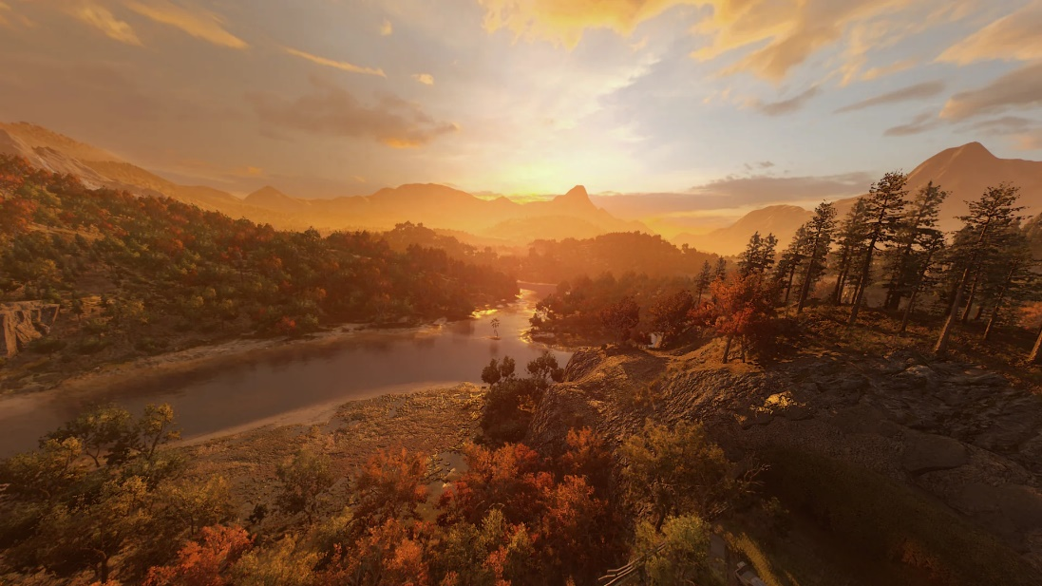

Dying Light 2: Let Power In

Version 2.0

|  |  |
| --- | --- |
| Designer: | Donghua Elish Li |
| Document Date: | 1/27/2024 |
| Intended Level Delivery Date: | 4/26/2024 |

**Document Revisions Table**

|  |  |  |  |
| --- | --- | --- | --- |
| **Version** | **Description** | **Requestor** | **Date** |
| 1.0 | Initial Document | Professor. Clark | 1/30/2024 |
| 2.0 | 2.0 Document | Professor. Clark | 5/7/2024 |
|  |  |  |  |
|  |  |  |  |
|  |  |  |  |

# Table of Contents

Table of Contents 2

Table of Figures 2

Level Summary 3

Quick Summary 3

Level Feature Overview 3

Development Schedule 4

Level Details 5

Level Map(s) 5

Overview Map 5

Detail Maps 6

Gameplay Summary 7

Skill Progression Chart 9

Appendix A: Aesthetic References 10

Landscape Overall Theme: Tranquil Valley with a central lake 10

POI Theme 11

Appendix B: Characters/Dialog Flow 12

Character 1: Hakon 12

Appendix C: Key Asset Needs 13

References 14

# Table of Figures

Figure 1: Overview Map [16] 5

Figure 2 Detail Map of Open World [16] 6

Figure 3 Detail Map of Buildings and Objective Areas [16] 7

Figure 4 Skill Progression Chart [17] 9

Figure 5 Contact Sheet of Exterior Landscape Aesthetic Theme [15] 10

Figure 6 Contact Sheet of Exterior POI Spots Aesthetic Theme [15] 11

Level Design Document

# Level Summary

## Quick Summary

Let Power In is a single-player level in Dying Light 2. It contains a side quest where the player, Aiden, is tasked by Hakon to help power up all electric towers in a valley to replenish electricity. It is an open-world level where the player can decide the order of visiting an electric power. The gameplay style in the level focuses on parkour and melee combat.

## Level Feature Overview

|  |  |  |
| --- | --- | --- |
| Category | Sub-Category | Feature List |
| Player | Player Weapons | * Bat * Machete * Axe |
|  | Player Skills/Abilities | * Climb, Jump * Slung on monkey bar * Slung on a hanging roll * Melee combat |
| AI | Enemies | * Viral * Biter * Banshee |
|  | Friendlies | * None |
| Challenges | Gameplay Themes | * Melee Combat * Parkour Run * Exploring level-items, consumables, and weapons |
|  | Obstacles/Hazards | N/A |
|  | New/Unique Gameplay | N/A |
| Context | Where Fits in Game | * It is a standalone side quest before Hakon gets injured by snipper |
|  | Challenge Fit | * The player needs to do exploration to   + Become more powerful against zombies   + Approach the objectives   + Increase stamina to use some shortcuts |
|  | Additional Info | N/A |
| Aesthetics | Major Visual Themes | * Valley covered with trees |
|  | Setting/Mood | * Tranquil but dangerous * Peaceful while zombies lurking within the woods |

## Development Schedule

|  |  |
| --- | --- |
| Milestone | Date |
| LDD | 1/30/2024 |
| Whitebox | 2/13/2024 |
| Initial Gameplay | 3/5/2024 |
| Gameplay Complete | 4/2/2024 |
| Aesthetics | 4/16/2024 |
| Launch | 4/26/2024 |

# Level Details

## Level Map(s)

### Overview Map

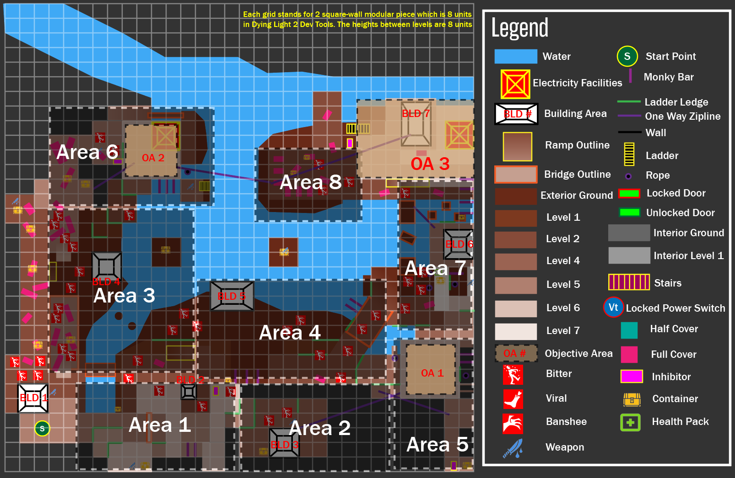

N

Figure 1: Overview Map [16]

### Detail Maps

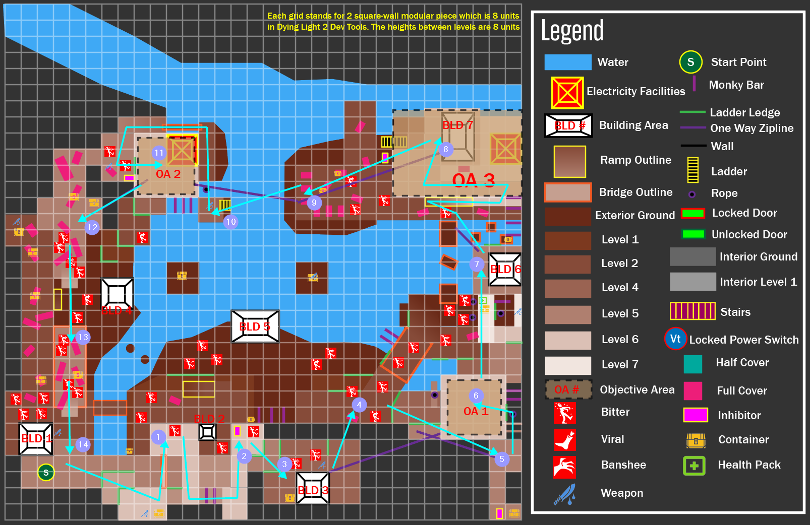

N

Figure 2 Detail Map of Open World [16]

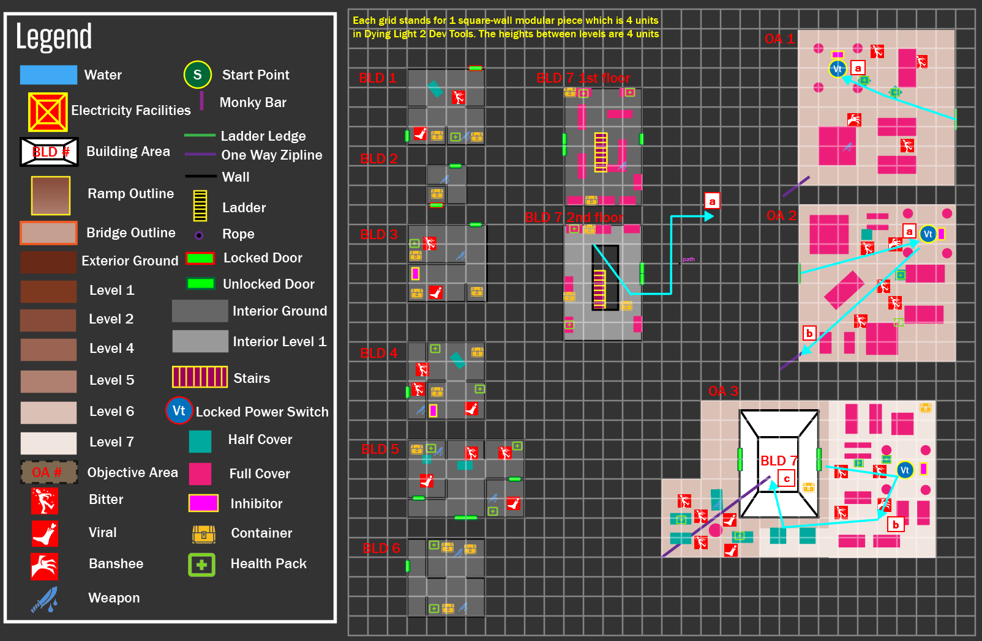

N

Figure 3 Detail Map of Buildings and Objective Areas [16]

## Gameplay Summary

**Note:**

1. **Because this level is an open-world level, this gameplay summary only includes one critical path that does not require using inhibitor to upgrade**
2. **In this game, the maximum distance that a player can jump without using any tools before upgrading any perks is 8 units**

|  |  |  |
| --- | --- | --- |
| Map Label | Gameplay Summary | Other Notes |
| 1 | Move Forward and see the platform at the right side by the ladder ledge on it;  Climb on the ladder ledge on them to get to the top of the platform;  Make a left turn and walk forward to another platform by going across the wooden log | At the start of the quest, the in-game time is fixed to the afternoon; |
| 2 | Defeat the bitte at front;  Make a right turn and move forward;  Jump on the monkey bar and perform two slung to reach the other side of the platform |  |
| 3 | Kill the zombie at front;  Make a right turn and go down to a **BLD3** in you sight |  |
| 4 | Defeat the zombies occupying **BLD 3** and leave it from the ramp in front of it |  |
| 5 | Move forward while killing the zombies on the way;  Make a right turn and climb up to the platform via the ladders on it for two times;  Take the zipline to reach another platform in far distance |  |
| 6 | Make a left turn;  Jump on the wooden bar sticking on the wall twice;  Grap the rope and climb up and jump to the ladder ledge;  Climb to the top of the wall and reach the platform where **OA1** is | In-game time is fixed to Dawn Time |
| 6.a | Move forward and defeat all zombies around;  Lockpick the power box and turn on the power switch;  Leave this facility |  |
| 7 | Jump down the platforms from the north side of OA1 until you reach the platform where two rope is in front of you;  Jump and grab the first rope and slung;  Release the rope and grab the second rope;  Slung and jump to the platform where **BLD 6** is |  |
| 8 | Take the zipline at front;  After landing, move forward while killing the enemies along the way;  Go upstairs and make a U turn at the end of the stairs’  Move forward and reach the front of **BLD 7**;  Kill the enemies gathering in front of **BLD 7**; |  |
| 8.a | Get into **BLD7** and reach the door at the second floor by the stairs |  |
| 8.b | Leave **BLD7** and enter **OA3**;  Move forward and kill the zombies nearby;  Lockpick the power box and turn on the power switch |  |
| 8.c | Turn around and climb to the roof of **BLD7**. There is a zipline there; | The in-game time is fixed to Sunset time |
| 9 | Take the zipline to leave **OA3** |  |
| 10 | After landing, jump down to the river bank;  Swim to move forward until you reach the opposite bank where a ladder is;  Climb the ladder to reach its top; |  |
| 11 | Turn right and jump to grab the rope;  Slung and jump to the opposite platform;  Move forward and make a left turn;  Go across the wooden log;  Move forward and make a left turn;  Kill the zombies at front;  Climb on the ladder ledge and reach **OA2** |  |
| 11.a | Move forward and kill all zombies at front;  Lockpick the power box and turn on the power switch |  |
| 11.b | Leave the electric facility;  Move to the southwest corner where a zipline is in **OA2** |  |
| 12 | Take the zipline until you land at its endpoint | The in-game time is fixed to the evening time. Night hunt is started. |
| 13 | Run southward to the end where a ramp is;  Sprint on the ramp and jump;  After landing, run southward to the end where a ramp is and jump again;  After returning to the start point, quest ends |  |

## Skill Progression Chart

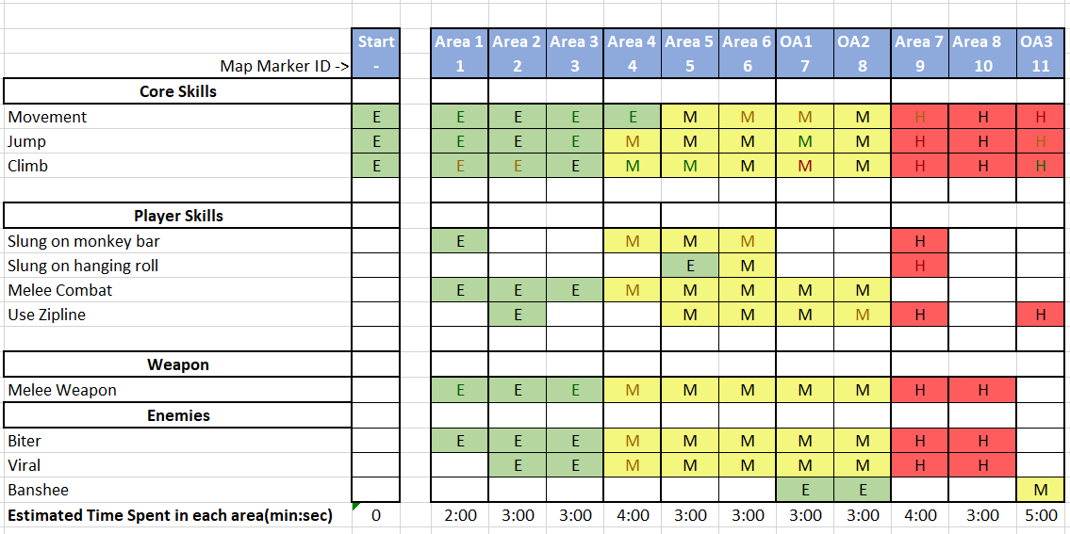



Figure 4 Skill Progression Chart [17]

**Note: This Skill Progression is created by estimating how player’s skills will advance from start point to OA3 area** **diagonally. Generally, the closer to the start point, the easier challenges the player will meet. Vice versa, the closer to the OA3 area, the harder challenges the player will meet.**

Appendices

# Appendix A: Aesthetic References

## Landscape Overall Theme: Tranquil Valley with a central lake

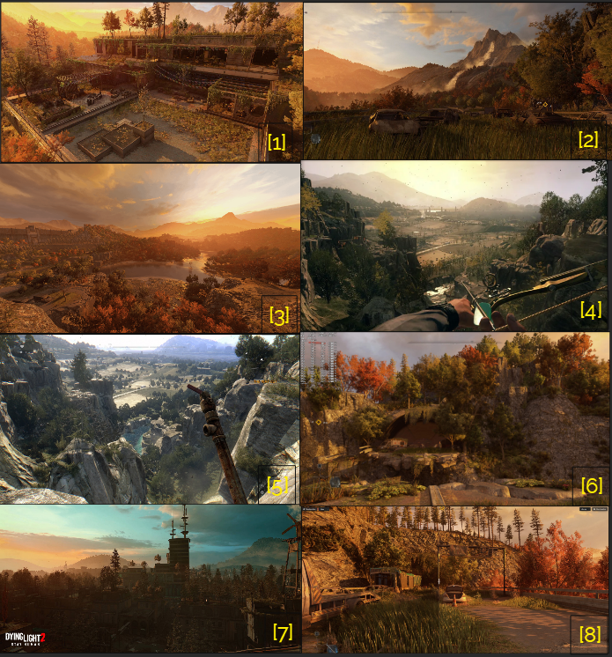

Figure 5 Contact Sheet of Exterior Landscape Aesthetic Theme [15]

## POI Theme

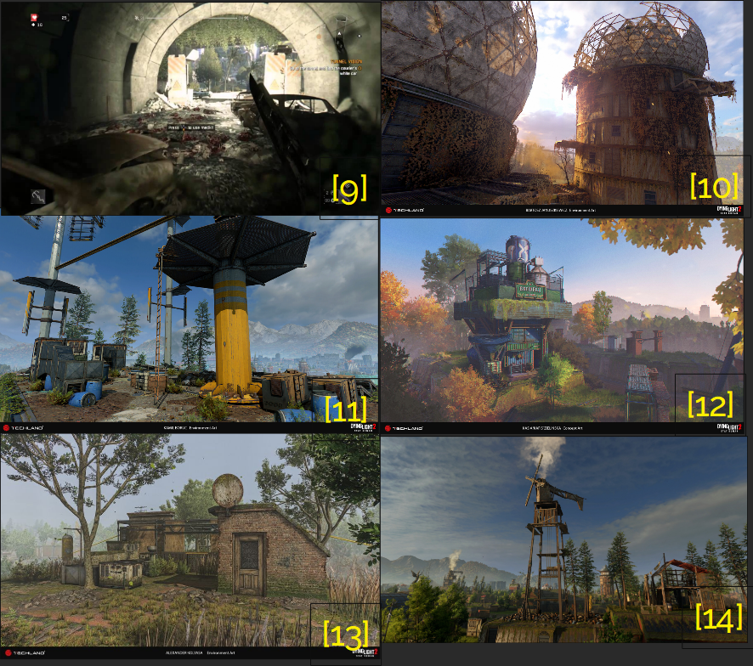

Figure 6 Contact Sheet of Exterior POI Spots Aesthetic Theme [15]

# Appendix B: Characters/Dialog Flow

## Character 1: Hakon

|  |  |
| --- | --- |
| **Description** | Hakon is the quest giver in this level. He won’t be in the level but using radio to talk with the player |
| **Background** | A friendly and previous nightrunner living in Villedor City. He knows lots of stuff in the city. |
| **Goals/Motivation** | Task the player to power up all observatories in the valley |
| **Personality/Archetype** | Reliable, brave, smart |
| **Relationships** | Friend |

# Appendix C: Key Asset Needs

|  |  |  |  |
| --- | --- | --- | --- |
| Prefix | Description | Type | Priority |
| pr_b | Prefix of prologue’s prefab for building a villa | Assets | High |
| uv_centre | Prefix of observatory building | Assets | High |
| tunnel | Keyword of tunnel | Assets | High |
| transf, electri | Prefix of stuffs related electric tower | Assets | Med |
| pa_ | Prefix of shed | Assets | Med |
| nat_ | Prefix of natural environment props | Assets | Low |
| int_ | Prefix of interior modular pieces | Assets | Med |
| hub_ | Prefix of cargo container modular pieces | Assets | Low |
| horizon_, hor_ | Prefix of distanced horizon assets | Assets | Low |
| frn_ | Prefix of furniture assets and shop assets | Assets | Low |
| dl_ | Prefix of dying light 1 assets | Assets | Low |
| ce_ | Prefix of railway and metro assets | Assets | Low |
| bld_ | Prefix of exterior building pieces | Assets | Med |
| River_ | Prefix of reiver bend pieces | Assets | Med |

# References

**Cover Image** [**https://www.reddit.com/r/dyinglight/comments/wmquc1/dying_light_2_prologue_pictures/**](https://www.reddit.com/r/dyinglight/comments/wmquc1/dying_light_2_prologue_pictures/)

[1]<https://www.reddit.com/r/dyinglight/comments/146p9ql/what_was_your_favourite_part_of_dying_light_2/>

[2] <https://www.notebookcheck.net/Dying-Light-2-in-test-Notebook-and-desktop-benchmarks.598202.0.html>

[3] <https://www.reddit.com/r/dyinglight/comments/wmquc1/dying_light_2_prologue_pictures/>

[4] <https://www.ebay.com/itm/403407441395>

[5] <https://gamingcentral.in/dying-light-enhanced-edition-review/dying-light-the-following-enhanced-edition_20160315135602/>

[6] <https://www.dsogaming.com/pc-performance-analyses/dying-light-2-nvidia-dlss-amd-fsr-ray-tracing-benchmarks/>

[7] <https://wallpapers.com/wallpapers/dying-light-2-forest-yhf49desmbjfd5py.html>

[8] <https://www.digitaltrends.com/computing/dying-light-2-pc-performance-best-settings-high-fps/>   
[9] <https://www.youtube.com/watch?v=3kLrtwH4vlE&ab_channel=SHOPHOTGAME>

[10] <https://www.artstation.com/artwork/NG2v5P>

[11] <https://www.artstation.com/artwork/G82gbV>

[12] <https://twitter.com/iamagco/status/1506267387129208838>

[13] <https://80.lv/articles/dying-light-2-designs-concept-art-by-techland-artists/>

[15] Li, Donghua, “Contact Sheet of Exterior POI Spots Aesthetic Theme” and “Contact Sheet of Exterior POI Spots Aesthetic Theme”, created by Pureref, Jan. 28, 2024.

[16] Li, Donghua, “Overview Map”, “Detail Map of Open World” and “Detail Map of Buildings and Objective Areas”, created by Adobe Illustrator, Jan. 29, 2024.

[17] Li, Donghua, “Skill Progression Chart”, created by Microsoft Excel, Jan. 29, 2024.